Milestone 3 : Creation of Access Control Lists(Read ACL)
- In the Application Navigator, search for System Security → Access Control (ACL).
- Elevate “Security_admin” role
- Click New to create a new ACL.
- Enter the following details:
  - Type: record
  - Operation: read
  - Name: u_institution_details
  - Active: true
  - Advanced: true
- In the Requires role related list, add:
  - bb1 (custom role)
- Add Data condition as Branch is EEE

- In the Script field, add the following script:
(function () {
// Allow admin users full access
if (gs.hasRole('admin')) {
return true;
}
// Allow only EEE branch users to see EEE records
if (gs.hasRole('bb1')){
return true;
}
// Deny access for all others
return false;
})();
- Click Submit to save the ACL.
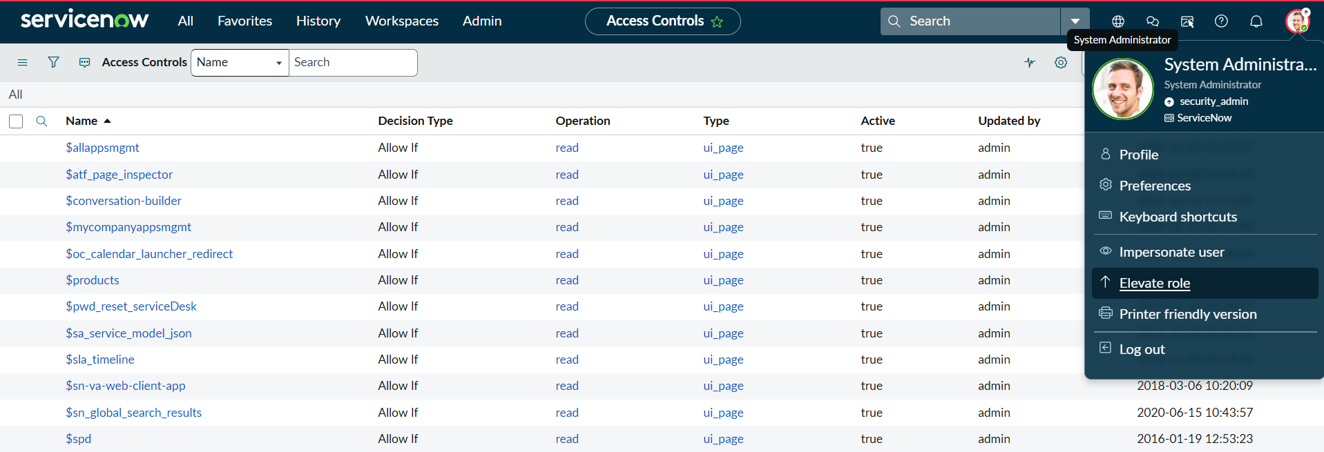
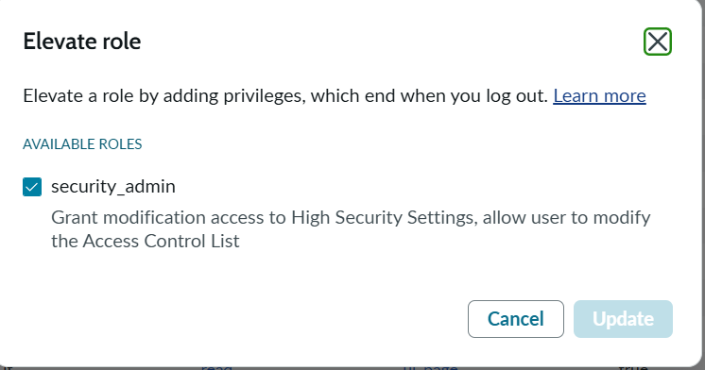
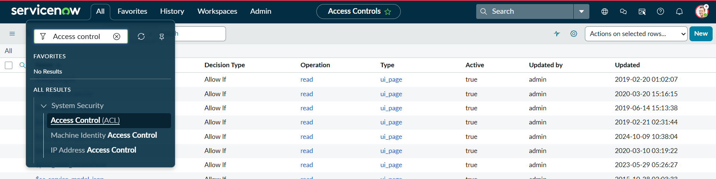
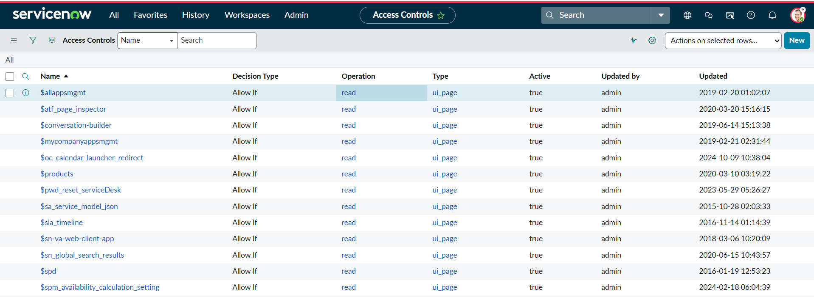
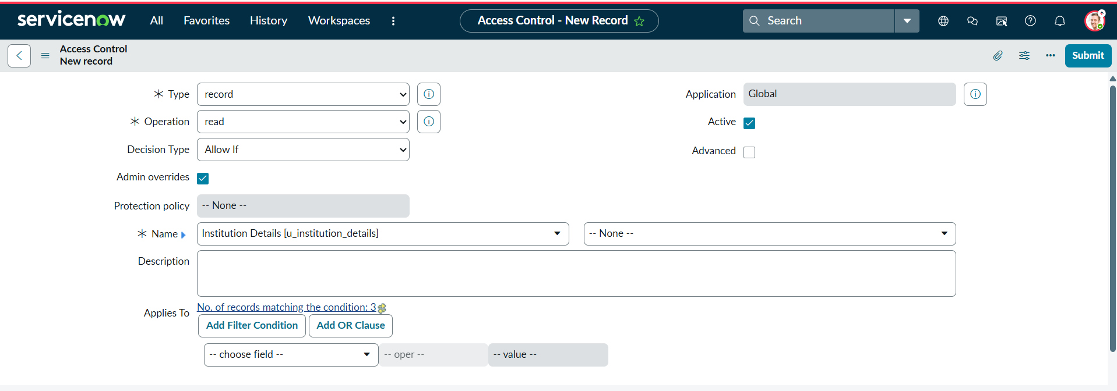
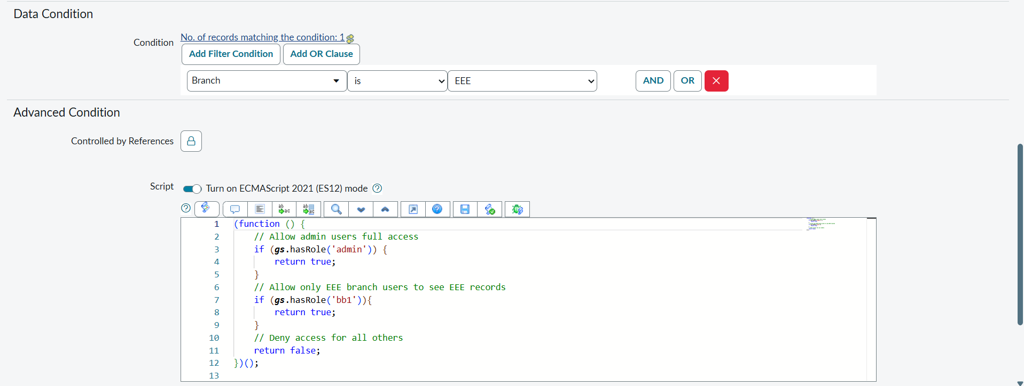
- Impersonate EEE users and open the Student Records list.
- Copy the table name u_institution_details.list/LIST and paste in the All menu.
- Impersonate Admin and open the Student Records list.

Verify :
- User with bb1 role can view only EEE branch records

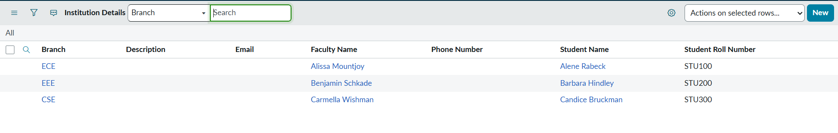
- User without the role cannot view any records

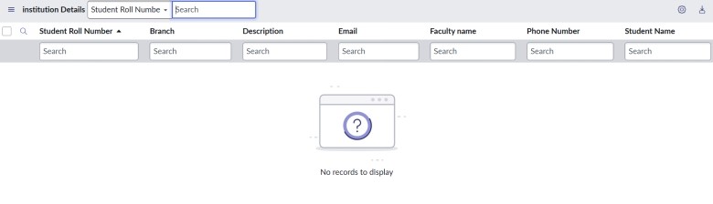

- Admin user can view all records regardless of branch

